**Forms - Department**

**COVER SHEET SET (2 pages):**

**REQUEST FOR PROPOSAL Page 1/2**

**RFP # 2012-0910 Expanded and Integrated HIV Testing Initiative**

##### DEPARTMENT OF PUBLIC HEALTH

**PUBLIC HEALTH INITIATIVES BRANCH**

**A. Applicant Information**

Applicant Agency:_____________________________________________________________________

Legal Name

____________________________________________________________________________________

Address

____________________________________________________________________________________

City/Town State Zip Code

__________________ _________________________ _____________________________

Telephone No. FAX No. E-Mail Address

Contact Person: __________________________________ Title: _______________________________

Telephone No: ___________________________

**TOTAL PROGRAM COST:** $__________________

I certify that to the best of my knowledge and belief, the information contained in this application is true and correct. The application has been duly authorized by the governing body of the applicant, the applicant has the legal authority to apply for this funding, the applicant will comply with applicable state and federal laws and regulations, and that I am a duly authorized signatory for the applicant.

_________________________________________ ______________________________________

Signature of Authorizing Official: Date

____________________________________________________________________________________

Typed Name and Title

--------------------------------------------------------------------------------------------------------------------------------------------

The applicant agency is the agency or organization, which is legally and financially responsible and accountable for the use and disposition of any awarded funds. Please provide the following information:

1. Full legal name of the organization or corporation as it appears on the corporate seal and as registered with the Secretary of State
2. Mailing address
3. Main telephone number
4. Fax number, if any
5. Principal contact person for the application (person responsible for developing application)
6. Total program cost

The funding application and all required submittals must include the signature of an officer of the applicant agency who has the legal authority to bind the organization. The signature, typed name and position of the authorized official of the applicant agency must be included as well as the date on which the application is signed.

**COVER SHEET Page 2/2**

**B. CONTRACTOR INFORMATION**

PLEASE LIST THE AGENCY CONTACT PERSONS RESPONSIBLE FOR COMPLETION AND SUBMITTAL OF:

**Contract and Legal Documents/Forms:**

|  |  |  |
| --- | --- | --- |
|  |  |  |
| Name | Title | Tel. No. |
|  |  |  |
| Street | Town | Zip Code |
|  | |  |
| Email | | Fax No. |

**Program Progress Reports:**

|  |  |  |
| --- | --- | --- |
|  |  |  |
| Name | Title | Tel. No. |
|  |  |  |
| Street | Town | Zip Code |
|  | |  |
| Email | | Fax No. |

**Financial Expenditure Reporting Forms:**

|  |  |  |  |  |
| --- | --- | --- | --- | --- |
|  | |  | |  |
| Name | | Title | | Tel. No. |
|  | |  | |  |
| Street | | Town | | Zip Code |
|  | | | |  |
| Email | | | | Fax No, |
| **Incorporated:** YES NO | | | **Agency Fiscal Year:** |  |
|  | | | | |
| **Type of Agency:** PublicPrivate Other, Explain: | | |  | |
| Profit Non-Profit | | |  | |
| **Federal Employer I.D. Number:** |  | | **Town Code No:** |  |
| **M****edicaid Provider Status:** YESNO | | | **Medicaid Number:** |  |
| **Minority Business Enterprise (MBE) :** YESNO | | | | |
| **Women Business Enterprise (MBE) :** YESNO | | | | |

**Budget Summary Instructions**

1. **Personnel** (lines #1 - #5) each person funded:
2. Name of person & Title
3. Hourly rate, # hours working per week, and # of weeks. (calculate)
4. Fringe benefit rate. (calculate)

**Example:**

|  |  |
| --- | --- |
| **1.** Name & Position: John Smith, Coordinator |  |
| Calculation: $25.00 hr X 35hrs X 45wks | $39,375 |
| Fringe Benefit: 26% | $10,238 |

1. Line #11 **Contractual (Subcontracts)** provide the total of all subcontracts and complete Subcontractor Schedule.
2. Lines #6 - #13 complete categories as appropriate,
3. Line # 14: Other Expenses are any other types of expense that do not fit into the categories listed.

For example: Equipment (purchasing a computer at a cost of $1,500). Please note that the state’s definition of equipment is tangible personal property with a normal useful life of at least one year and a value of at least $2,500 or more.

1. **\*\*\*Audit Costs,** the cost of audits made in accordance with OMB Circular A133 (Federal Single Audit) are allowable charges to Federal awards. The costs of State Single Audits (CGS 4-23 to 4-236) are allowable charges to State awards. Audit costs are allowable to the extent that they represent a pro-rata share of the cost of such audit. Audit costs charged to Department of Public Health contracts **must be budgeted, reported and justified as an audit cost line item within the Administrative and General Cost category.**
2. Line Item #15 **Administrative and General Costs**, these are defined as those costs that have been incurred for the overall executive and administrative offices of the organization or other expenses of a general nature that do not relate solely to any major cost objective of the overall organization. Examples of A&G costs include salaries of executive directors, administrative & financial personnel, accounting, auditing, management information systems, proportional office costs such as building occupancy, telephone, equipment, and office supplies. Please review the OPM website on Cost Standards for more information at: <http://www.ct.gov/opm/cwp/view.asp?a=2981&q=382994>.
3. **Administrative and General Costs** must be itemized on the Budget Justification Schedule. Costs that have a separate line item in the Budget Summary may not be duplicated as an Administrative and General Cost. For example, if the Budget Summary includes an amount for telephone costs, this cannot also be included as an Administrative and General Cost.
4. **Other Income** list any other program income such as in-kind contributions, fees collected, or other funding sources and include brief explanation on Budget Justification.
5. **2 Year Contracts:** 2 sets of budget forms have been provided. Please do a full budget for each year of the contract, clearly indicating the year on each form. Assume level funding for the second year.

Note: If space allowed is not sufficient for large or complex subcontract budgets, the Budget Summary format may be copied and used instead.

**Budget Justification Schedule Instructions**

1. Please provide a brief explanation for each line item listed on the Budget Summary. This must include a detailed breakdown of the components that make up the line item and any calculation used to compute the amount.

\*\*\****Please note: If Laboratory Services is a line item or subcontractor, please supply a justification as to why a private laboratory is being used as opposed to the Connecticut State Laboratory.***

1. For contractors who have subcontracts, a brief description of the purpose of each subcontract must be provided. Use additional sheets as necessary.

**Example:**

|  |  |  |
| --- | --- | --- |
| **Line Item (Description)** | **Amount** | **Justification — Breakdown of Costs** |
| **Travel** | $730 | 1,659 miles @ .44 = $730.00 outreach workers going to meetings and site visits. |

**C. Subcontractor Schedule A—Detail**

1. All subcontractors used by each program must be included, if it is not known who the subcontractor will be, an estimated amount and whatever budget detail is anticipated should be provided. (Submit the actual detail when it is available). A separate subcontractor schedule must be completed for each program included in the contract. For example: The contract is providing both a Needle Exchange program and an AIDS Prevention Education Program and Subcontractor “A” is providing services to both program there must be a separate budget for Subcontractor “A” for each.
2. **Detail of Each Subcontractor:**

Choose a category below for each subcontract using the basis by which it is paid:

**A.** Budget Basis  **B.** Fee for Service  **C.** Hourly Rate.

Provide the detail for each subcontract referencing the corresponding program of the contract. Detail must be provided for each subcontractor listed in the Summary.

**Example A. Budget Basis**

|  |  |
| --- | --- |
| Outreach Educator $20/hr x 20hrs/wk x 50wks | $20,000 |
| Travel 590 miles @ .44 cents/mile | 260 |
| Supplies | 500 |
| Total | $20,760 |

**Example B. Fee for Service:**

|  |  |
| --- | --- |
| Develop and Produce |  |
| 500 Videos @ $10 each | $5,000 |
| Total |  |

**Example C. Hourly Rate:**

|  |  |
| --- | --- |
| Quality Assurance Review of 200 Patient Charts |  |
| by Nurse Clinician 200 hours @ $25/hour | $5,000 |
| Total | $5,000 |

\*\*\****Please note: If Laboratory Services is a line item or subcontractor, please supply a justification as to why a private laboratory is being used as opposed to the Connecticut State Laboratory.***

**BUDGET SUMMARY**

|  |  |
| --- | --- |
| **Category** | **Amount** |
| **Personnel:** |  |
| 1. Name & Position:      , |  |
| Calculation: |  |
| Fringe Benefit:      % |  |
|  |  |
| 1. Name & Position:      , |  |
| Calculation: |  |
| Fringe Benefit:      % |  |
|  |  |
| 1. Name & Position:      , |  |
| Calculation: |  |
| Fringe Benefit:      % |  |
|  |  |
| 1. Name & Position:      , |  |
| Calculation: |  |
| Fringe Benefit:      % |  |
|  |  |
| 1. Name & Position:      ,      : |  |
| Calculation: |  |
| Fringe Benefit:      % |  |
|  |  |
| 1. Travel      per mile X      miles |  |
| 1. Office Supplies |  |
| 1. Medical Materials |  |
| 1. Contractual (Subcontracts)**\*\*\* must be included in budget summary** |  |
| 1. Telephone |  |
| 1. Other Expenses (List Below) |  |
|  |  |
|  |  |
|  |  |
|  |  |
|  |  |
|  |  |
| 1. Administrative and General Costs * |  |
| **Total DPH Grant** |  |
|  |  |
| Other Program Income: |  |

*** See Subcontractor Schedule

**\* Administrative Costs shall not exceed 15% of the direct service costs.**

**BUDGET JUSTIFICATION SCHEDULE**

|  |  |  |
| --- | --- | --- |
| **Line Item (Description)** | **Amount** | **Justification including Breakdown of Costs** |
|  |  |  |
|  |  |  |
|  |  |  |
|  |  |  |
|  |  |  |
|  |  |  |
|  |  |  |
|  |  |  |
|  |  |  |
|  |  |  |
|  |  |  |
|  |  |  |
|  |  |  |
|  |  |  |
|  |  |  |
|  |  |  |
|  |  |  |
|  |  |  |
|  |  |  |
|  |  |  |
|  |  |  |
|  |  |  |

**SUBCONTRACTOR SCHEDULE DETAIL**

**#1**

**Program:**

Subcontractor Name:

Address:

Telephone: (     ) (     -     )

Select One: **A**  Budget Basis **B**  Fee-for-Service **C**  Hourly Rate

Indicate One:  MBE  WBE  Neither

|  |  |
| --- | --- |
| Line Item | Amount |
|  |  |
|  |  |
|  |  |
|  |  |
|  |  |
| Total Subcontract Amount: |  |

**#2**

Subcontractor Name:

Address:

Telephone: (     ) (     -     )

Select One: **A**  Budget Basis **B**  Fee-for-Service **C**  Hourly Rate

Indicate One:  MBE  WBE  Neither

|  |  |
| --- | --- |
| Line Item | Amount |
|  |  |
|  |  |
|  |  |
|  |  |
|  |  |
| Total Subcontract Amount: |  |

**#3**

Subcontractor Name:

Address:

Telephone: (     ) (     -     )

Select One: **A**  Budget Basis **B**  Fee-for-Service **C**  Hourly Rate

Indicate One:  MBE  WBE  Neither

|  |  |
| --- | --- |
| Line Item | Amount |
|  |  |
|  |  |
|  |  |
|  |  |
|  |  |
| Total Subcontract Amount: |  |

**STAFFING PROFILE: Profile of Staff Providing Services.**

Please provide the information requested below**.**

|  |  |  |  |  |
| --- | --- | --- | --- | --- |
| Professional Staff* | Name | Title | Hourly  Rate | Assigned to Project:  # hrs/wk |
|  |  |  |  |  |
| Position 1 |  |  |  |  |
|  |  |  |  |  |
|  |  |  |  |  |
| Position 2 |  |  |  |  |
|  |  |  |  |  |
|  |  |  |  |  |
| Position 3 |  |  |  |  |
|  |  |  |  |  |
|  |  |  |  |  |
| Position 4 |  |  |  |  |
|  |  |  |  |  |
|  |  |  |  |  |
| Clerical/  Support Staff: |  |  |  |  |
|  |  |  |  |  |
|  |  |  |  |  |
| Position 1 |  |  |  |  |
|  |  |  |  |  |
|  |  |  |  |  |
| Position 2 |  |  |  |  |
|  |  |  |  |  |
|  |  |  |  |  |

**\*Attach Resumes for all Professional Staff**

**Work plan (make as many blank pages as needed):**

|  |  |  |  |  |
| --- | --- | --- | --- | --- |
| **Services to be Provided**  (Routine HIV Screening) | **Activities**  (Who, What, When, Where, etc.) | **Staff Position(s) Responsible** | **Expected Outcomes**  (# of HIV Tests conducted, # of referrals to partner services, # of referrals to medical care and other services, etc.) | **Timetable**  (Dates) |
|  |  |  |  |  |
|  |  |  |  |  |
|  |  |  |  |  |
|  |  |  |  |  |
|  |  |  |  |  |
|  |  |  |  |  |
|  |  |  |  |  |
|  |  |  |  |  |
|  |  |  |  |  |
|  |  |  |  |  |
|  |  |  |  |  |
|  |  |  |  |  |
|  |  |  |  |  |
|  |  |  |  |  |
|  |  |  |  |  |
|  |  |  |  |  |
|  |  |  |  |  |
|  |  |  |  |  |
|  |  |  |  |  |
|  |  |  |  |  |
|  |  |  |  |  |
|  |  |  |  |  |
|  |  |  |  |  |
|  |  |  |  |  |

**2. OTHER . . . . . . . . . . . . . . . . . .**

**Notification to Bidders**

**NOTIFICATION TO BIDDERS**

The contract to be awarded is subject to contract compliance requirements mandated by Sections 4a-60 and 4a-60a of the Connecticut General Statutes; and, when the awarding agency is the State, Sections 46a-71 (d) and 46a-81i (d) of the Connecticut General Statutes. There are Contract Compliance Regulations codified at Section 46a-68j-21 through 46a-68j-43 of the Regulations of Connecticut State agencies, which establish a procedure for the awarding of all contracts covered by Sections 4a-60 and 46a-71 (d) of the Connecticut General Statutes.

According to Section 46a-68j-30 (9) of the Contract Compliance Regulations, every agency awarding a contract subject to the contract compliance requirements has an obligation to “aggressively solicit the participation of legitimate minority business enterprises as bidders, contractors, subcontractors and suppliers of materials.” “Minority Business Enterprise” is defined in Section 4a-60 of the Connecticut General Statutes as a business wherein fifty-one percent or more of the capital stock, or assets belong to a person or persons: “(1) Who are active in the daily affairs of the enterprise; (2) Who have the power to direct the management and policies of the enterprise; and, (3) Who are members of a minority, as such term is defined in subsection (a) of Section 32-9n.” “Minority” groups are defined in Section 32-9n of the Connecticut General Statutes as “(1) Black Americans ... (2) Hispanic Americans ... (3) Women ... (4) Asian Pacific Americans and Pacific Islanders; or (5) American Indians.” The above definitions apply to the contract compliance requirements by virtue of Section 46a-68j-21 (11) of the Contract Compliance Regulations.

The awarding agency will consider the following factors when reviewing the bidder’s qualifications under the contract compliance requirements.

1. the bidder’s success in implementing an affirmative action plan;
2. the bidder’s success in developing an apprenticeship program complying with Sections 46a-68-1 to 46a-68-18 of the Connecticut General Statutes, inclusive;
3. the bidder’s promise to develop and implement a successful affirmative action plan;
4. the bidder’s submission of EEO-1 data indicating the composition of its workforce is at or near parity when compared to the racial and sexual composition of the workforce in the relevant labor market area; and,
5. the bidder’s promise to set aside a portion of the contract for legitimate minority business enterprises. See Section 46a-68j-30 (10) (E) of the Contract Compliance Regulations.

**INSTRUCTION**: Bidder must sign acknowledgment below line and return acknowledgment to Awarding Agency along with the bid proposal.

The undersigned acknowledges receiving and reading a copy of the “Notification to Bidders” form.

_______________________________________ ___________________________

Signature Date

On behalf of:

**Acknowledgment of Contract Compliance**

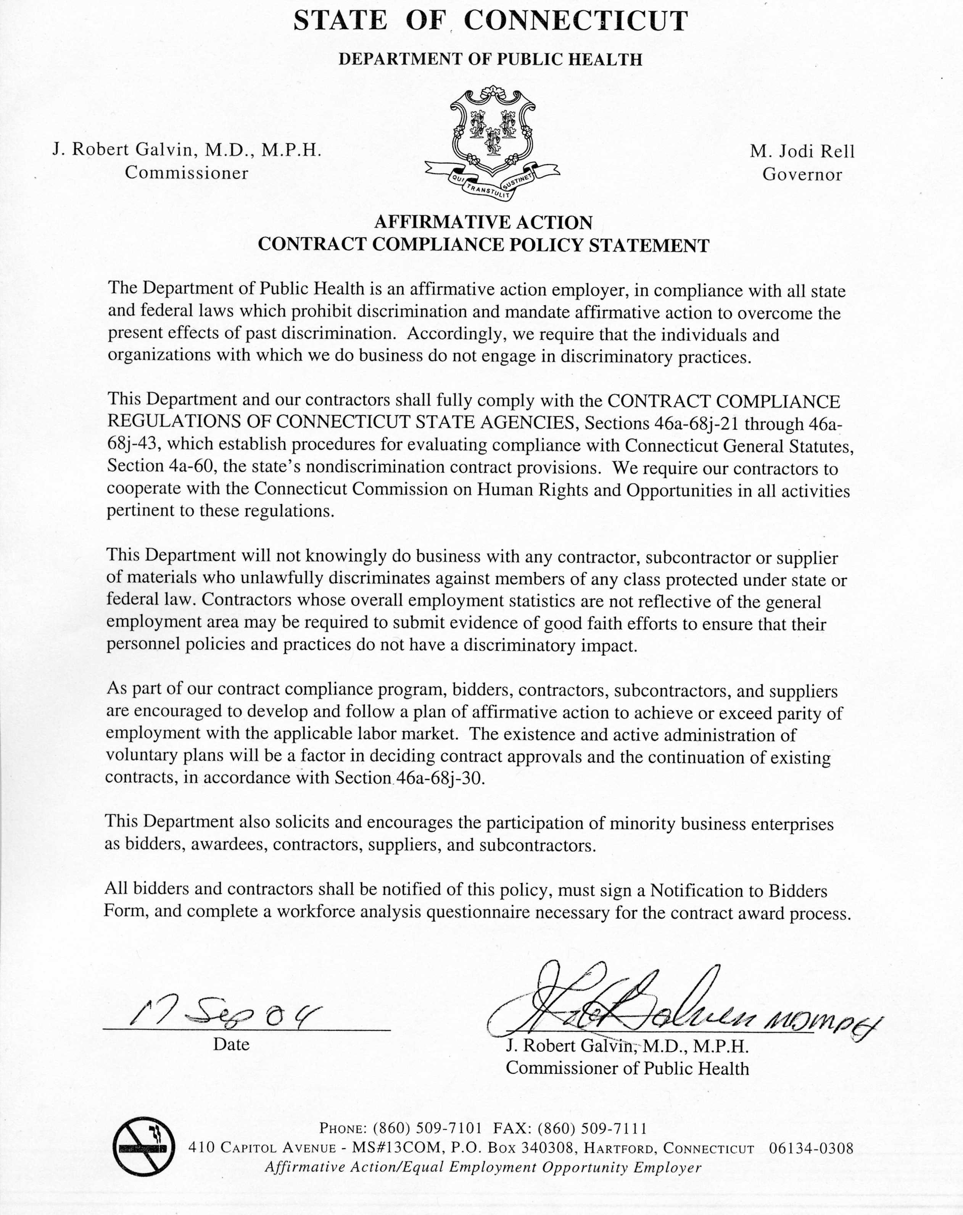

**WORKFORCE ANALYSIS**

|  |  |  |  |  |  |  |  |  |  |  |  |  |  |  |  |  |
| --- | --- | --- | --- | --- | --- | --- | --- | --- | --- | --- | --- | --- | --- | --- | --- | --- |
| **WORKFORCE ANALYSIS** | | | | | | | | | | | | | | | | |
| Contractor Name: | | | | | | | | Total Number of CT employees: | | | | | | | | |
| Address: | | | | | | | | Full Time: | | | | Part Time: | | | | | |
|  | | | | | | | |  | | | | | | | | |
| Complete the following Workforce Analysis for employees on Connecticut worksites who are: | | | | | | | | | | | | | | | | |
| Job Categories | Overall Totals  (sum of all cols. Male & female) | White  (not of Hispanic Origin) | | Black  (not of Hispanic Origin) | | Hispanic | | | Asian or Pacific Islander | | American Indian or Alaskan Native | | | | People with  Disabilities | | |
|  | | Male | Female | Male | Female | Male | | Female | Male | Female | Male | | Female | | Male | Female |
| Officials & Managers | |  |  |  |  |  | |  |  |  |  | |  | |  |  |
| Professionals | |  |  |  |  |  | |  |  |  |  | |  | |  |  |
| Technicians | |  |  |  |  |  | |  |  |  |  | |  | |  |  |
| Office & Clerical | |  |  |  |  |  | |  |  |  |  | |  | |  |  |
| Craft Workers  (skilled) | |  |  |  |  |  | |  |  |  |  | |  | |  |  |
| Operatives  (semi-skilled) | |  |  |  |  |  | |  |  |  |  | |  | |  |  |
| Laborers  (unskilled) | |  |  |  |  |  | |  |  |  |  | |  | |  |  |
| Service Workers | |  |  |  |  |  | |  |  |  |  | |  | |  |  |
| Totals Above | |  |  |  |  |  | |  |  |  |  | |  | |  |  |
| Totals 1 year Ago | |  |  |  |  |  | |  |  |  |  | |  | |  |  |
| FORMAL ON-THE-JOB TRAINEES (Enter figures for the same categories as are shown above) | | | | | | | | | | | | | | | | |
| Apprentices | |  |  |  |  |  | |  |  |  |  | |  | |  |  |
| Trainees | |  |  |  |  |  | |  |  |  |  | |  | |  |  |
| EMPLOYMENT FIGURES WERE OBTAINED FROM: | | | | | | | Visual Check: | | | Employment Records | | | | Other: | | |
|  | | | | | | | | | | | | | | | | |
| 1. Have you successfully implemented an Affirmative Action Plan?  YES  NO  Date of implementation:__________________If the answer is “No”, explain.  a) Do you promise to develop and implement a successful Affirmative Action?  YES  NO  Not Applicable Explanation:  2. Have you successfully developed an apprenticeship program complying with Sec. 46a-68-1 to 46a-68-18 of the Connecticut Department of Labor Regulations, inclusive:  YES  NO  Not Applicable Explanation: | | | | | | | | | | | | | | | | |
| 3. According to EEO-1 data, is the composition of your work force at or near parity when compared with the racial and sexual composition of the work force in the relevant labor market area?  YES  NO Explanation: | | | | | | | | | | | | | | | | |

If you plan to subcontract, will you set aside a portion of the contract for legitimate minority business enterprises?

YES  NO Explanation:

_______________________________________ ________________________

Contractor’s Authorized Signature Date

**CONSULTING AGREEMENT AFFIDAVIT (OPM Ethics Form 5)**

|  |  |
| --- | --- |
| armbear | **STATE OF CONNECTICUT**  **CONSULTING AGREEMENT AFFIDAVIT** |

Affidavit to accompany a State contract for the purchase of goods and services with a value of $50,000 or more in a calendar or fiscal year, pursuant to Connecticut General Statutes §§ 4a-81(a) and 4a-81(b)

**INSTRUCTIONS:**

**If the bidder or vendor has entered into a consulting agreement, as defined by Connecticut General Statutes § 4a-81(b)(1):**  Complete all sections of the form. If the bidder or vender has entered into more than one such consulting agreement, use a separate form for each agreement. Sign and date the form in the presence of a Commissioner of the Superior Court or Notary Public. **If the bidder or vendor has not entered into a consulting agreement, as defined by Connecticut General Statutes § 4a-81(b)(1):** Complete only the shaded section of the form. Sign and date the form in the presence of a Commissioner of the Superior Court or Notary Public.

Submit completed form to the awarding State agency with bid or proposal. For a sole source award, submit completed form to the awarding State agency at the time of contract execution.

This affidavit must be amended if the contractor enters into any new consulting agreement(s) during the term of the State contract.

**AFFIDAVIT:** [ Number of Affidavits Sworn and Subscribed On This Day: _____ ]

I, the undersigned, hereby swear that I am the chief official of the bidder or vendor awarded a contract, as described in Connecticut General Statutes § 4a-81(a), or that I am the individual awarded such a contract who is authorized to execute such contract. I further swear that I have not entered into any consulting agreement in connection with such contract, **except for the agreement listed below**:

__________________________________________ _______________________________________

Consultant’s Name and Title Name of Firm (if applicable)

__________________ ___________________ ___________________

Start Date End Date Cost

Description of Services Provided: ___________________________________________________________

Is the consultant a former State employee or former public official? ⬜ YES ⬜ NO

If YES: ___________________________________ __________________________

Name of Former State Agency Termination Date of Employment

Sworn as true to the best of my knowledge and belief, subject to the penalties of false statement.

|  |  |  |
| --- | --- | --- |
|  |  |  |
| Printed Name of Bidder or Vendor | **Signature of Chief Official or Individual** | **Date** |
|  |  |  |
|  |  | Dept. of Public Health |
|  | Printed Name (of above) | Awarding State Agency |

**Sworn and subscribed before me on this _______ day of ____________, 200__.**

**Commissioner of the Superior Court or Notary Public**

|  |
| --- |
| **V. ATTACHMENTS** |

***This section is for informational and proposer checklist purposes only.***

* **Proposer’s Minimum Requirement Check list**

*(Note: This check list will be used by DPH as step one of the RFP Review Process)*

* **State of Connecticut Nondiscrimination Certification**

*(Note: The successful proposer must complete and submit the applicable and appropriate nondiscrimination certification form to the Connecticut Department of Public Health prior to contract execution).*

* **Gift and Campaign Contributions**

*(Note: The successful proposer must complete and submit OPM Ethics Form 1 to the Department of Public Health prior to contract execution)*

* **HIV Test Forms 1, 2, and 3 (Appendix I)**

**SECTION V. ATTACHMENTS**

**PROPOSER’S MINIMUM REQUIREMENTS CHECKLIST: RFP #2012-0910**

**Proposer must submit a separate and complete proposal with all required forms and attachments for each service component proposed**

Applicant

1. Cover pages (See Section IV. I. Forms) completed and included in proposal ________

(not included in page limit)

2. Executive Summary (1 page maximum per service component) included ________

(not included in page limit)

3. Declaration of Confidential Information referenced or indicated as N/A ________

(not included in page limit)

4. Conflict of Interest Disclosure Statement included ________

(not included in page limit)

5. Main Proposal narrative meets respective page limits ________

6. Resumes provided for all professional staff assigned to this project. ________

(not included in page limit)

7. Job descriptions provided for all key personnel assigned to this project

including new positions being proposed ________

(not included in page limit)

8. Staff Profile form completed and included in proposal ________

(not included in page limit)

9. Budget Summary and Budget Justification Forms completed and included in proposal ________

(not included in page limit)

10. Subcontractor Schedule (if applicable) completed and included in proposal ________

(not included in page limit)

11. Completed Work Plan form included in proposal ________

(not included in page limit)

12. Completed Notification to Bidders form included in proposal. ________

(not included in page limit)

13. Completed Workforce Analysis Questionnaire included in proposal. ________

(not included in page limit)

14. Signed Consulting Agreement Affidavit (OPM Ethics Form 5) included in proposal ________

(not included in page limit)

### An original unbound and 6 unbound copies of the completed proposal (s) must be received ________

at DPH no later than **February 14, 2012 by 4:00 p.m**.

16. The proposal is signed by an authorized official of the Applicant Organization.________

### SECTION V. ATTACHMENTS : Non-Discrimination Certification

|  |  |
| --- | --- |
| armbear | **STATE OF CONNECTICUT Form B**  **NONDISCRIMINATION CERTIFICATION — Representation 7/8/09**  **By Entity**  **For Contracts Valued at Less Than $50,000** |
|  |  |

*Written representation that complies with the nondiscrimination agreements and warranties under Connecticut General Statutes §§ 4a-60(a)(1) and 4a-60a(a)(1), as amended*

**INSTRUCTIONS:**

For use by an entity (corporation, limited liability company, or partnership) when entering into any contract type with the State of Connecticut **valued at less than $50,000 for each year of the contract**. Complete all sections of the form. Submit to the awarding State agency prior to contract execution.

**REPRESENTATION OF AN ENTITY:**

|  |  |  |  |  |  |  |
| --- | --- | --- | --- | --- | --- | --- |
| I, |  | , |  | of |  | , |
|  | Authorized Signatory |  | Title | Name of Entity | | |

|  |  |  |
| --- | --- | --- |
| an entity duly formed and existing under the laws of |  | , |
|  | Name of State or Commonwealth |  |

represent that I am authorized to execute and deliver this representation on behalf of

|  |  |  |
| --- | --- | --- |
|  | and that |  |
| Name of Entity |  | Name of Entity |

has a policy in place that complies with the nondiscrimination agreements and warranties of Connecticut

General Statutes §§ 4a-60(a)(1) and 4a-60a(a)(1), as amended.

|  |  |  |  |
| --- | --- | --- | --- |
|  |  |  |  |
| Authorized Signature |  | Date |  |
|  |  |  |  |
|  |  |  |  |
|  |  |  |  |
| Printed Name |  |  |  |
|  |  |  |  |

|  |
| --- |
| armbear**STATE OF CONNECTICUT Form C**  **NONDISCRIMINATION CERTIFICATION — Affidavit By Entity**  **7/8/09**  **For Contracts Valued at $50,000 or More** |
|  |

*Documentation in the form of an affidavit signed under penalty of false statement by a chief executive officer, president, chairperson, member, or other corporate officer duly authorized to adopt corporate, company, or partnership policy that certifies the contractor complies with the nondiscrimination agreements and warranties under Connecticut General Statutes §§ 4a-60(a)(1) and 4a-60a(a)(1), as amended*

**INSTRUCTIONS:**

For use by an entity (corporation, limited liability company, or partnership) when entering into any contract type with the State of Connecticut **valued at $50,000 or more for any year of the contract**. Complete all sections of the form. Sign form in the presence of a Commissioner of Superior Court or Notary Public. Submit to the awarding State agency prior to contract execution.

**AFFIDAVIT:**

I, the undersigned, am over the age of eighteen (18) and understand and appreciate the obligations of an oath.

|  |  |  |  |  |  |
| --- | --- | --- | --- | --- | --- |
| I am |  | of |  | , an entity |  |
|  | Signatory’s Title |  | Name of Entity |  | |

|  |  |
| --- | --- |
| duly formed and existing under the laws of | . |
|  | Name of State or Commonwealth |

I certify that I am authorized to execute and deliver this affidavit on behalf of

|  |  |  |
| --- | --- | --- |
|  | and that |  |
| Name of Entity |  | Name of Entity |

has a policy in place that complies with the nondiscrimination agreements and warranties of Connecticut

General Statutes §§ 4a-60(a)(1)and 4a-60a(a)(1), as amended.

|  |  |  |  |
| --- | --- | --- | --- |
|  |  |  |  |
| Authorized Signature |  |  |  |
|  |  |  |  |
|  |  |  |  |
|  |  |  |  |
| Printed Name |  |  |  |
|  |  |  |  |

**Sworn and subscribed to before me on this** ______ **day of** ____________**, 20__**__**.**

___________________________________________ ___________________________________

**Commissioner of the Superior Court/ Notary Public Commission Expiration Date**



|  |  |
| --- | --- |
| armbear | **STATE OF CONNECTICUT**  **GIFT AND CAMPAIGN CONTRIBUTION CERTIFICATION** |

Certification to accompany a State contract with a value of $50,000 or more in a calendar or fiscal year, pursuant to C.G.S. §§ 4-250 and 4-252I; Governor M. Jodi Rell’s Executive Orders No. 1, Para. 8, and No. 7C, Para. 10; and C.G.S. §9-612(g)(2), as amended by Public Act 07-1

**INSTRUCTIONS:**

Complete all sections of the form. Attach additional pages, if necessary, to provide full disclosure about any lawful campaign contributions made to campaigns of candidates for statewide public office or the General Assembly, as described herein. Sign and date the form, under oath, in the presence of a Commissioner of the Superior Court or Notary Public. Submit the completed form to the awarding State agency at the time of initial contract execution (and on each anniversary date of a multi-year contract, if applicable).

**CHECK ONE:**  Initial Certification  Annual Update (Multi-year contracts only.)

**GIFT CERTIFICATION:**

As used in this certification, the following terms have the meaning set forth below:

1. “Contract” means that contract between the State of Connecticut (and/or one or more of it agencies or instrumentalities) and the Contractor, attached hereto, or as otherwise described by the awarding State agency below;
2. If this is an Initial Certification, “Execution Date” means the date the Contract is fully executed by, and becomes effective between, the parties; if this is an Annual Update, “Execution Date” means the date this certification is signed by the Contractor;
3. “Contractor” means the person, firm or corporation named as the contactor below;
4. “Applicable Public Official or State Employee” means any public official or state employee described in C.G.S. §4-252I(1)(i) or (ii);
5. **“Gift”** has the same meaning given that term in C.G.S. § 4-250(1);
6. “Planning Start Date” is the date the State agency began planning the project, services, procurement, lease or licensing arrangement covered by this Contract, as indicated by the awarding State agency below; and
7. “Principals or Key Personnel” means and refers to those principals and key personnel of the Contractor, and its or their agents, as described in C.G.S. §§ 4-250(5) and 4-252I(1)(B) and (C).

I, the undersigned, am the official authorized to execute the Contract on behalf of the Contractor. I hereby certify that,between the Planning Start Date and Execution Date, neither the Contractor nor any Principals or Key Personnel has made, will make (or has promised, or offered, to, or otherwise indicated that he, she or it will, make) any **Gifts** to any Applicable Public Official or State Employee.

I further certify that no Principals or Key Personnel know of any action by the Contractor to circumvent (or which would result in the circumvention of) the above certification regarding **Gifts** by providing for any other principals, key personnel, officials, or employees of the Contractor, or its or their agents, to make a **Gift** to any Applicable Public Official or State Employee. I further certify that the Contractor made the bid or proposal for the Contract without fraud or collusion with any person.

**CAMPAIGN CONTRIBUTION CERTIFICATION:**

I further certify that, on or after December 31, 2006, neither the Contractor nor any of its principals, as defined in C.G.S. § 9-612(g)(1), has made any **campaign** **contributions** to, or solicited any contributions on behalf of, any exploratory committee, candidate committee, political committee, or party committee established by, or supporting or authorized to support, any candidate for statewide public office, in violation of C.G.S. § 9-612(g)(2)(A). I further certify that **all** **lawful** **campaign contributions** that have been made on or after December 31, 2006 by the Contractor or any of its principals, as defined in C.G.S. § 9-612(g)(1), to, or solicited on behalf of, any exploratory committee, candidate committee, political committee, or party committee established by, or supporting or authorized to support any candidates for statewide public office or the General Assembly, are listed below:

**STATE OF CONNECTICUT**

**GIFT AND CAMPAIGN CONTRIBUTION CERTIFICATION**

**Lawful Campaign Contributions to Candidates for Statewide Public Office:**

Contribution Date Name of Contributor Recipient Value Description

**Lawful Campaign Contributions to Candidates for the General Assembly:**

Contribution Date Name of Contributor Recipient Value Description

Sworn as true to the best of my knowledge and belief, subject to the penalties of false statement.

|  |  |  |
| --- | --- | --- |
|  |  |  |
| Printed Contractor Name |  | Signature of Authorized Official |

**Subscribed and acknowledged before me on this _________ day of ________________, 200__.**

**Commissioner of the Superior Court (or Notary Public)**

|  |  |  |
| --- | --- | --- |
| For State Agency Use Only |  |  |
| Department of Public Health |  |  |
| Awarding State Agency |  | Planning Start Date |
|  | | |
| Contract Number or Description | | |

**Appendix I**

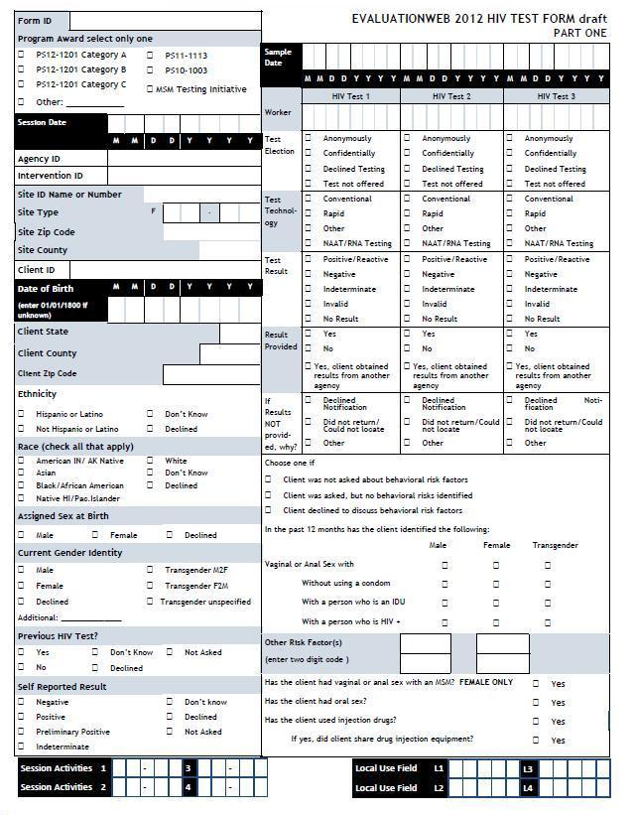

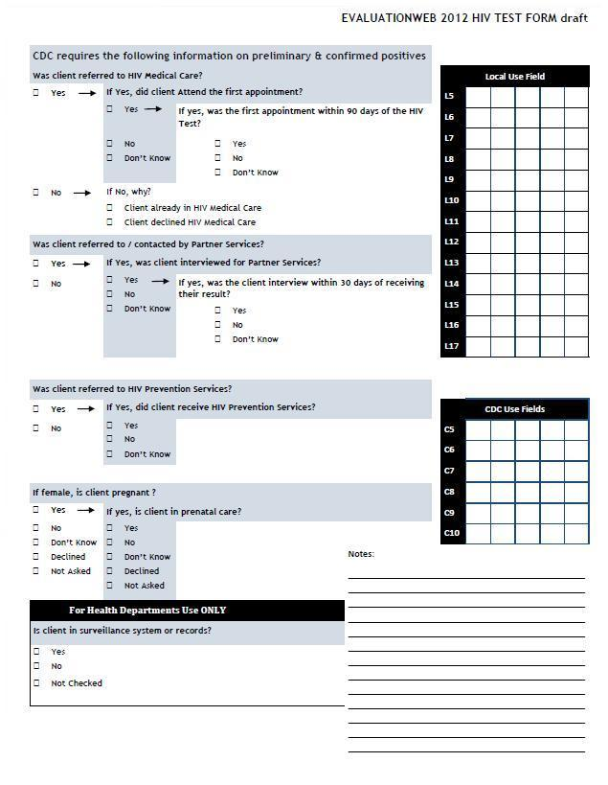

h

